

عنوان البحث

........................................................................................................................................................................

|  |  |
| --- | --- |
| كلـــــــــــــــية | : الهندسة الالكترونية بمنوف |
| القســم/الشعبة | :عام |
| الفرقـة/المستوي | :الأولى |
| اســــم المقـــرر | : Electrical Power |
| كــــود المقــــرر | : ACE124 |
| اســـــم الطالب | :عبدالرحمن عمادالدين محمد الشافعي |
| الرقـــم القومي | :30004301700253 |
| البريد الأكاديمي | :ab.al.shafei@el-eng.menofia.edu.eg |
| اشـــــــــــــراف | : أ.د./ حمدي عواد  : أ.د./ عصام جمعة |

**Abstract**

It is essential for electrical power engineers to reduce the number of outages and preserve the continuity of service and electric supply. Therefore, it is necessary to direct special attenuation towards the protection of transmission lines and power apparatus from the chief causes of overvoltages in electric systems, namely lightning overvoltages and switching overvoltages. Lightning overvoltage is a natural phenomenon, while switching overvoltages originate in the system itself by the connection and disconnection of circuit breaker contacts or due to initiation or interruption of faults.

**Introduction**

Till the time when the transmission voltages were about 220 kV and below, overvoltages due to lightning were of very high order and overvoltages generated inside the system were not of much consequence. In later years, with increase in transmission voltages (400 kV and above), the overvoltages generated inside the system reached the same order of magnitude as those of lightning overvoltages, or higher. Secondly, the overvoltages thus generated last for longer durations and therefore are severe and more dangerous to the system. Unlike the lightning overvoltages, the switching and other types of overvoltages depend on the normal voltage of the system and hence increase with increased system voltage. In insulation co-ordination, where the protective level of any kind of surge diverter is proportional to the maximum voltage, the insulation level and the cost of the equipment depends on the magnitudes of these overvoltages. In the EHV range, it is the switching surge and other types of overvoltages that determine the insulation level of the lines and other equipment and consequently, they also determine their dimensions and costs.

**Research Project Contents**

Power System Protection is a fascinating subject. A protection scheme in a power

system is designed to continuously monitor the power system to ensure maximum

continuity of electrical supply with minimum damage to life, equipment, and property.

While designing the protective schemes, one has to understand the fault characteristics

of the individual power system elements. One should also be knowledgeable about the

tripping characteristics of various protective relays. The design has to ensure that relays will detect undesirable conditions and then trip to disconnect the area affected, but remain restrained at all other times However, there is statistical evidence that a large number of relay trippings are due to improper or inadequate settings than due to genuine faults. A lot of detective work is usually undertaken to understand the reason behind the tripping. It needs to be established why the relay has tripped. Whether it should

have tripped at all. What and where was the fault? These are some of the questions

required to be answered. This is because a power system is a highly complex and

dynamic entity. It is always in a state of flux. Generators may be in or out of service.

New loads are added all the time. A single malfunction at a seemingly unimportant

location has the potential to trigger a system-wide disturbance. In view of such possible

consequences, a protective system with surgical accuracy is the only insurance against

potentially large losses due to electrical faults. Protective relays are meant to mitigate the effects of faults. However, it is ironic that every additional protective relay also increases the possibility of disturbance by way of its (relay's) own malfunction. The modem society has come to depend heavily upon continuous and reliable availability of electricity-and a high quality of electricity too. Computer and telecommunication networks, railway networks, banking and post office networks, continuous process industries and life support systems are just a few applications that just cannot function without a highly reliable source of electric power. And add to this, the mind-boggling number of domestic users of electricity whose life is thrown out of gear, in case the electric supply is disrupted. Thus, the importance of maintaining continuous supply of electricity round the clock cannot be overemphasized.

**Grounding**:

The term grounding is commonly used in the electrical industry to mean both “equipment grounding” and “system grounding”.

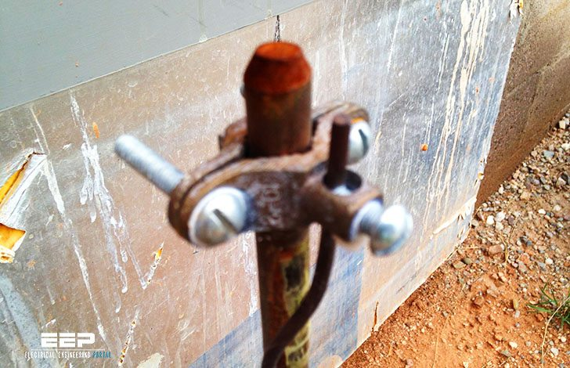

**Equipment grounding** means the connection of earth ground to non-current carrying conductive materials such as conduit, cable trays, junction boxes, enclosures, and motor frames.

**System grounding** means the connection of earth ground to the neutral points of current carrying conductors such as the neutral point of a circuit, a transformer, rotating machinery, or a system, either solidly or with a current-limiting device.

Figure 1 illustrates the two types of grounding.

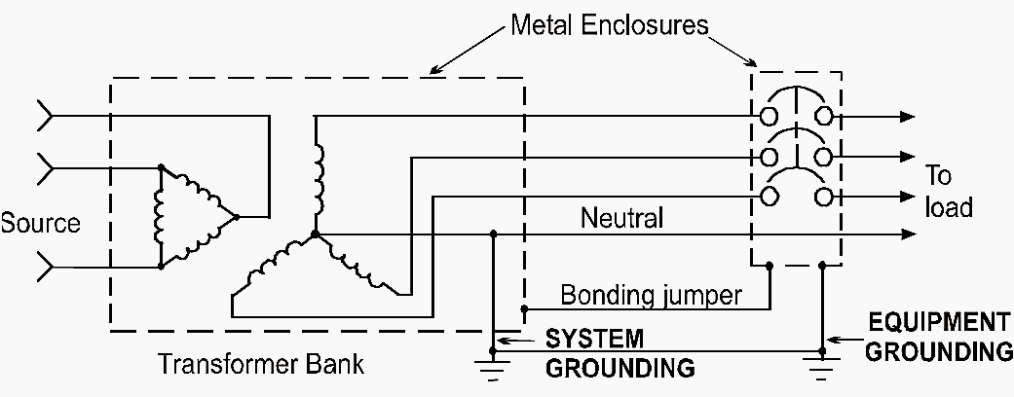

Figure 1 – Grounding system

**Grounded system** is a system in which at least one conductor or point is intentionally grounded, either solidly or through an impedance. System grounding, or the intentional connection of a phase or neutral conductor to earth, is for the purpose of controlling the voltage to earth, or ground, within predictable limits. It also provides for a flow of current that will allow detection of an unwanted connection between system conductors and ground [a ground fault].

**Ground fault** A ground fault is an unwanted connection between the system conductors and ground. Ground faults often go unnoticed and cause havoc on plant production processes. Shutting down power and damaging equipment, ground faults disrupt the flow of products, leading to hours or even days of lost productivity. Undetected ground faults pose potential health and safety risks to personnel. Ground faults can lead to safety hazards such as equipment malfunctions, fire, and electric shock. Ground faults cause serious damage to equipment and to your processes.

**Sources of surge and its methods of Protections:**

The making and breaking of electric circuits with switch gear may result in abnormal overvoltages in power systems having large inductances and capacitances. The overvoltages may go as high as six times the normal power frequency voltage. In circuit breaking operation, switching surges with a high rate of rise of voltage may cause repeated restriking of the arc between the contacts of a circuit breaker, thereby causing destruction of the circuit breaker contacts.

**Characteristics of Switching Surges:**

The waveshapes of switching surges (see fig 8.16a to e) are quite different and may have origin from any of the following sources:

* De-energizing of transmission lines, cables, shunt capacitor, capacitor banks, banks, etc.
* Disconnection of unloaded transformers, reactors, etc.
* Energization or reclosing of lines and reactive loads
* Sudden switching off of loads
* Short circuits and fault clearances
* Resonance phenomenon like ferro-resonance, arcing grounds, etc.

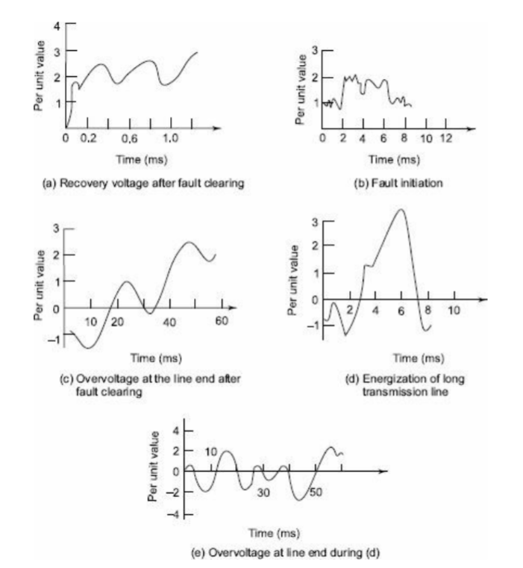

Fig. 8.16 Typical waveshapes of switching surge voltages

From the figures of the switching surges it is clear that the overvoltages are irregular (oscillatory or unipolar) and can be of high frequency or power frequency with its harmonics. The relative magnitudes of the overvoltages may be about 2.4 p.u. in the case of transformer energizing and 1.4 to 2.0 p.u. in switching transmission lines.

(a) Switching Overvoltages in EHV and UHV Systems

The different situations under which this happens are summarized as

* interruption of low inductive currents (current chopping) by high speed circuit breakers. This
* occurs when the transformers or reactors are switched off
* interruption of small capacitive currents, such as switching off of unloaded lines, etc.
* ferro-resonance condition
* This may occur when poles of a circuit breaker do not close simultaneously
* energization of long EHV or UHV lines

Transient overvoltages in the above cases can be of the order of 2.0 to 3.3 p.u. and will have magnitudes of the order of 1200 kV to 2000 kV on 750 kV systems. The duration of these overvoltages varies from 1 to 10 ms depending on the circuit parameters. It is seen that these are of comparable magnitude or even higher than those that occur due to lightning. The other situations of switching that give rise to switching overvoltages of short duration (0.5 to 5 ms) and lower magnitudes (2.0 to 2.5 p.u.) are

1. single pole closing of circuit breaker
2. interruption of fault current when the L-G or L-L fault is cleared
3. resistance switching used in circuit breakers
4. switching lines terminated by transformers
5. series capacitor compensated lines
6. sparking of the surge diverter located at the receiving end of the line to limit the lightning overvoltages

The overvoltages due to the above conditions are studied or calculated from

1. mathematical modelling of a system using digital computers
2. scale modelling using transient network analyzers
3. by conducting field tests to determine the expected maximum amplitude of the overvoltages and their duration at different points on the line. The main factors that are investigated in the above studies are

* the effect of line parameters, series capacitors and shunt reactors on the magnitude and duration of the transients.
* the damping factors needed to reduce the magnitude of over-voltages
* the effect of single pole closing, restriking and switching with series resistors in circuit breakers on the overvoltages, and
* the lightning arrester spark over characteristics.

It is necessary in EHV and UHV systems to control the switching surges to a safe value of less than 2.5 p.u. or preferably to 2.0 p.u. or even less. The measures taken to control or reduce the overvoltages are

* one step or multi-step energization of lines by preinsertion of resistors,
* phase controlled closing or circuit breakers with proper sensors,
* drainage of trapped charges on long lines before the reclosing of the lines, and
* limiting the overvoltages by using surge diverters.

The first three methods, if used properly will limit the switching overvoltages between 1.5 to 2.0 p.u.

In Table 8.1, a summary of the extent of overvoltages that can be developed under various conditions of switching is given.

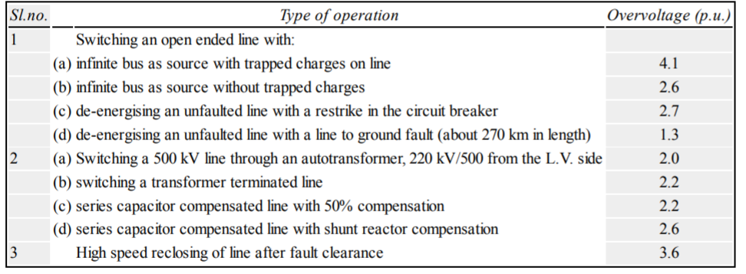

**Control of Overvoltages due to Switching:**

The overvoltages due to switching and power frequency may be controlled by

* 1. energization of transmission lines in one or more steps by inserting resistances and withdrawing them afterwards,
  2. phase-controlled closing of circuit breakers,
  3. drainage of trapped charges before reclosing,
  4. use of shunt reactors, and
  5. limiting switching surges by suitable surge diverters.

**Protection of Transmission Lines against Overvoltages:**

Protection of transmission lines against natural or lightning overvoltages and minimizing the lightning overvoltages are done by suitable line designs, providing guard and ground wires, and using surge diverters. Switching surges and power frequency overvoltages are accounted for by providing greater insulation levels and with proper insulation coordination.

**Protection against Lightning Overvoltages and Switching Surges of Short Duration**

Overvoltages due to lightning strokes can be avoided or minimized in practice by

1. shielding the overhead lines by using ground wires above the phase wires,
2. using ground rods and counter-poise wires, and
3. including protective devices like expulsion gaps, protector tubes on the lines, and surge diverters at the line terminations and substations.

**(a) Lightning Protection Using Shielded Wires or Ground Wires** Ground wire is a

conductor run parallel to the main conductor of the transmission line supported on the same tower and earthed at every equally and regularly spaced towers. It is run above the main conductor of the line. The ground wire shields the transmission line conductor from induced charges, from clouds as well as from a lightning discharge. The arrangements of ground wires over the line conductor is shown in Fig. 8.20. The mechanism by which the line is protected may be explained as follows. If a positively charged cloud is assumed to be above the line, it induces a negative charge on the portion below it, of the transmission line. With the ground wire present, both the ground wire and the line conductor get the induced charge. But the ground wire is earthed at regular intervals, and, as such, the induced charge is drained to the earth; only the potential difference between the ground wire and the cloud and that between the ground wire and the transmission line wire will be in the inverse ratio of their respective capacitances. As the ground wire is nearer to the line wire, the induced charge on it will be much less and hence the potential rise will be quite small. The effective protection or shielding given by the ground wire depends on the height of the ground wire above the ground (h) and the protection or shielding angle $θ_{s}$ (usually 30°) as shown in Fig. 8.20.

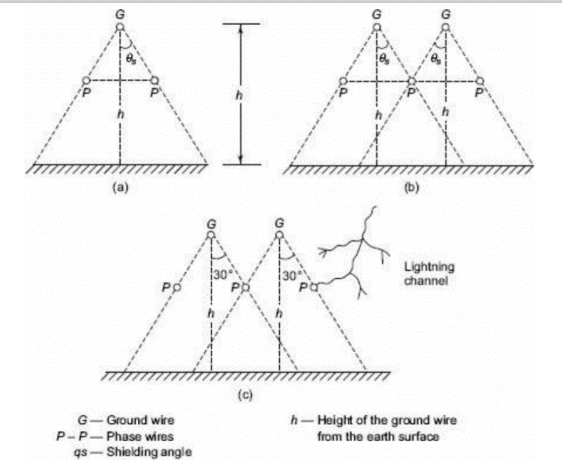

Fig. 8.20 Shielding arrangement of overhead lines by ground wires

The shielding angle $θ_{s} ≈ 30°$ was considered adequate for tower heights of 30 m or less. The shielding wires may be one or more depending on the type of the towers used. But for EHV lines, the tower heights may be up to 50 m, and the lightning strokes sometimes occur directly to the line wires as shown in Fig. 8.20. The present trend in fixing the tower heights and shielding angles is by considering the ‘flashover rates’ and failure probabilities.

$$V_{T}=\frac{I_{∘}Z_{T}}{1+\frac{z_{T}}{Z_{S}}}$$

**(b) Protection Using Ground Rods and Counter-Poise Wires.** The path for drainage of the charge and lightning current is:

1. through the tower frame to ground,
2. through the ground line in opposite directions from the point of striking.

**(c) Protective Devices**

In regions where lightning strokes are intense or heavy, the overhead lines within these zones are fitted with shunt protected devices. On the line itself two devices known as expulsion gaps and protector tubes are used. Line terminations, junctions of lines, and sub-stations are usually fitted with surge arresters.

1. **Expulsion Gaps** Expulsion gap is a device which consists of a spark gap together with an arcquenching device which extinguishes the current arc when the gaps breakover due to overvoltages. A typical such arrangement is shown in Fig. 8.21a.
2. **Protector Tubes** A protector tube is similar to the expulsion gap, in construction and principle. It also consists of a rod or spark gap in air formed by the line conductor and its high-voltage terminal. It is mounted underneath the line conductor on a tower. The arrangement is shown in Fig. 8.21b.

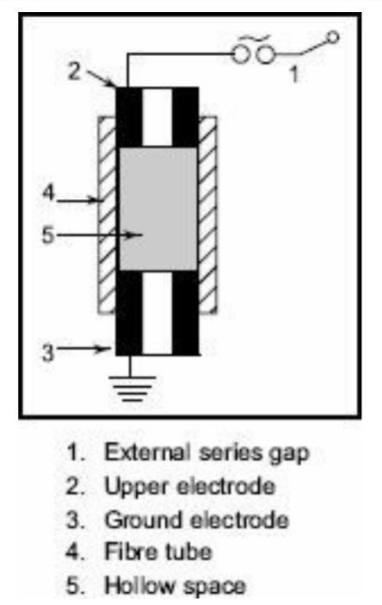

Fig. 8.21a Expulsion gap

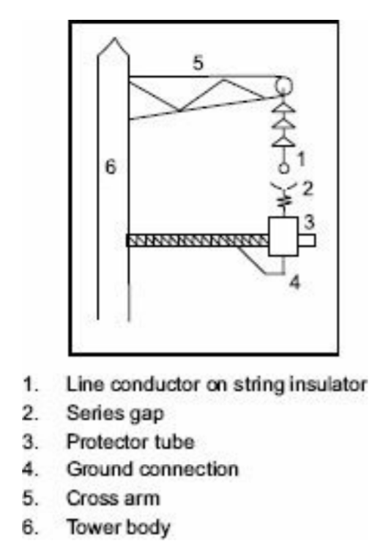

Fig. 8.21b Protector tube mounting

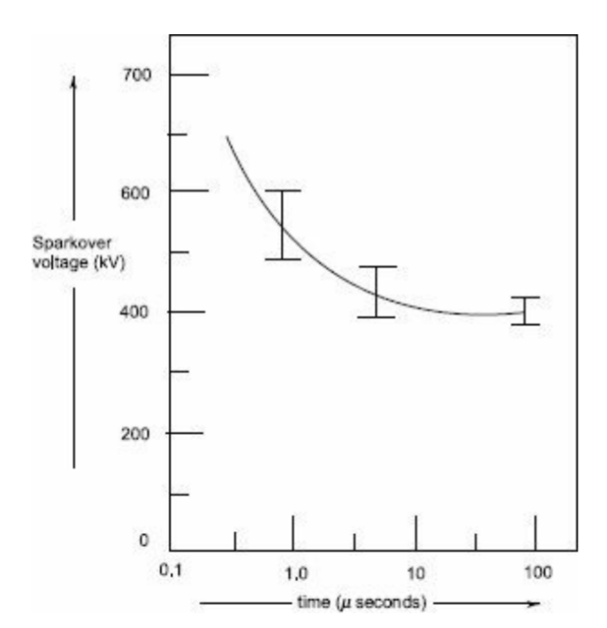

Fig. 8.22 Volt-time characteristic of a standard rod-rod gap

1. **Rod Gaps** A much simpler and effective protection device is a rod-gap. However, it does not meet the complete requirement. The sparkover voltage of a rod gap depends on the atmospheric conditions. A typical volt-time characteristic of a 67 cm-rod gap is shown in Fig. 8.22, with its protective margin.
2. **Surge Arresters** or Lightning Arresters Surge diverters or lightning arresters are devices used at sub-stations and at line terminations to discharge the lightning overvoltages and short duration switching surges. These are usually mounted at the line end at the nearest point to the sub-station. They have a flashover voltage lower than that of any other insulation or apparatus at the sub-station. These are capable of discharging 10 to 20 kA of long duration surges (8/20 μs) and 100 to 250 kA of the short duration surge currents (1/5 μs).

**References**

Write the references of the research project in this part.

1. S. Surges, "Switching Surges: Part IV-Control and Reduction on AC Transmission Lines," in IEEE Transactions on Power Apparatus and Systems, vol. PAS-101, no. 8, pp. 2694-2702, Aug. 1982, doi: 10.1109/TPAS.1982.317640..
2. Reference 2.
3. Reference 3.
4. Reference 4.
5. Reference 5.

المراجع: يكتب فيها أسماء المراجع المرتبطة بالمشروع البحثي بشرط لا تقل عن 5 مراجع وان يكون معظمها من بنك المعرفة المصري.